1 run......

Downloading: 100%

411/411 [00:00<00:00, 15.3kB/s]

Downloading: 100%

263M/263M [00:05<00:00, 44.9MB/s]

training 1 epoch...

70.98910641670227 seconds used......

1 training finished! average train loss: 0.9960750621699151

evaluating...

Confusion matrix, without normalization

[[ 80 38 6]

[ 42 112 10]

[423 116 326]]

Normalized confusion matrix

[[0.64516129 0.30645161 0.0483871 ]

[0.25609756 0.68292683 0.06097561]

[0.48901734 0.13410405 0.37687861]]

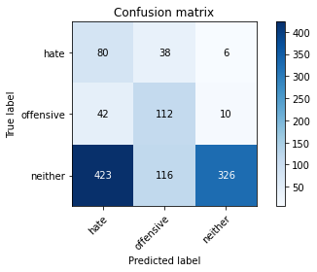

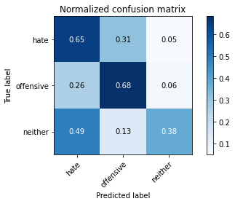

precision recall f1-score support

hate 0.15 0.65 0.24 124

offensive 0.42 0.68 0.52 164

neither 0.95 0.38 0.54 865

accuracy 0.45 1153

macro avg 0.51 0.57 0.43 1153

weighted avg 0.79 0.45 0.51 1153

average eval_loss: 0.950197377081575, accuracy: 0.4492627927146574

training 2 epoch...

70.13980340957642 seconds used......

2 training finished! average train loss: 0.85943674828325

evaluating...

Confusion matrix, without normalization

[[ 94 26 4]

[ 38 122 4]

[537 112 216]]

Normalized confusion matrix

[[0.75806452 0.20967742 0.03225806]

[0.23170732 0.74390244 0.02439024]

[0.62080925 0.12947977 0.24971098]]

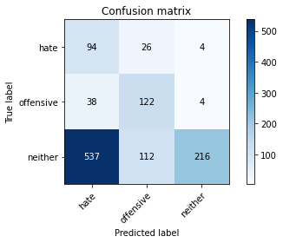

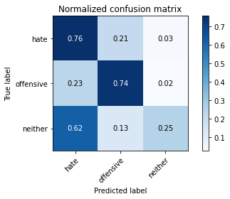

precision recall f1-score support

hate 0.14 0.76 0.24 124

offensive 0.47 0.74 0.58 164

neither 0.96 0.25 0.40 865

accuracy 0.37 1153

macro avg 0.52 0.58 0.40 1153

weighted avg 0.81 0.37 0.40 1153

average eval_loss: 1.054067231457809, accuracy: 0.3746747614917606

training 3 epoch...

70.09913492202759 seconds used......

3 training finished! average train loss: 0.7111780588470754

evaluating...

Confusion matrix, without normalization

[[ 90 27 7]

[ 39 116 9]

[452 84 329]]

Normalized confusion matrix

[[0.72580645 0.21774194 0.05645161]

[0.23780488 0.70731707 0.05487805]

[0.52254335 0.09710983 0.38034682]]

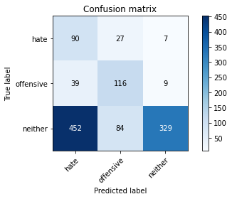

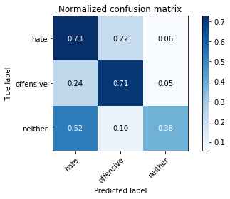

precision recall f1-score support

hate 0.15 0.73 0.26 124

offensive 0.51 0.71 0.59 164

neither 0.95 0.38 0.54 865

accuracy 0.46 1153

macro avg 0.54 0.60 0.46 1153

weighted avg 0.80 0.46 0.52 1153

average eval_loss: 1.1240783950378155, accuracy: 0.4640069384215091

training 4 epoch...

70.02148532867432 seconds used......

4 training finished! average train loss: 0.4772702381014824

evaluating...

Confusion matrix, without normalization

[[ 89 24 11]

[ 44 108 12]

[481 72 312]]

Normalized confusion matrix

[[0.71774194 0.19354839 0.08870968]

[0.26829268 0.65853659 0.07317073]

[0.55606936 0.08323699 0.36069364]]

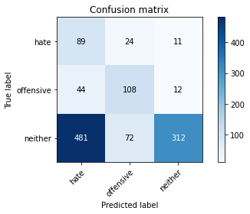

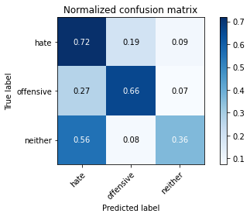

precision recall f1-score support

hate 0.14 0.72 0.24 124

offensive 0.53 0.66 0.59 164

neither 0.93 0.36 0.52 865

accuracy 0.44 1153

macro avg 0.54 0.58 0.45 1153

weighted avg 0.79 0.44 0.50 1153

average eval_loss: 1.4565100865117435, accuracy: 0.4414570685169124

training 5 epoch...

70.03013205528259 seconds used......

5 training finished! average train loss: 0.23117222763331874

evaluating...

Confusion matrix, without normalization

[[ 88 18 18]

[ 40 112 12]

[357 53 455]]

Normalized confusion matrix

[[0.70967742 0.14516129 0.14516129]

[0.24390244 0.68292683 0.07317073]

[0.41271676 0.06127168 0.52601156]]

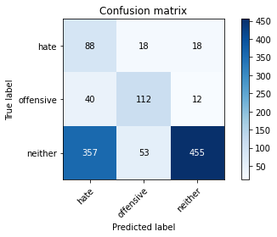

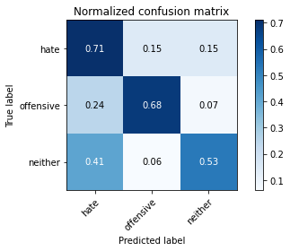

precision recall f1-score support

hate 0.18 0.71 0.29 124

offensive 0.61 0.68 0.65 164

neither 0.94 0.53 0.67 865

accuracy 0.57 1153

macro avg 0.58 0.64 0.54 1153

weighted avg 0.81 0.57 0.63 1153

average eval_loss: 1.3912221964063316, accuracy: 0.5680832610581092

training 6 epoch...

70.0911238193512 seconds used......

6 training finished! average train loss: 0.11101359128397667

evaluating...

Confusion matrix, without normalization

[[ 88 20 16]

[ 43 111 10]

[436 64 365]]

Normalized confusion matrix

[[0.70967742 0.16129032 0.12903226]

[0.26219512 0.67682927 0.06097561]

[0.50404624 0.07398844 0.42196532]]

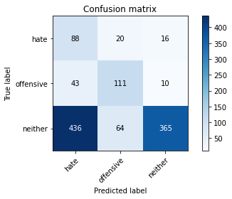

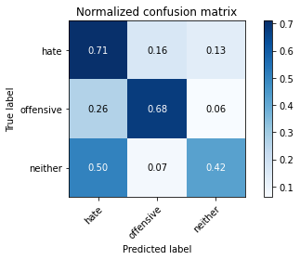

precision recall f1-score support

hate 0.16 0.71 0.25 124

offensive 0.57 0.68 0.62 164

neither 0.93 0.42 0.58 865

accuracy 0.49 1153

macro avg 0.55 0.60 0.48 1153

weighted avg 0.80 0.49 0.55 1153

average eval_loss: 2.3586521950261345, accuracy: 0.4891587163920208

training 7 epoch...

70.0935742855072 seconds used......

7 training finished! average train loss: 0.06447339048221086

evaluating...

Confusion matrix, without normalization

[[ 91 27 6]

[ 36 121 7]

[506 105 254]]

Normalized confusion matrix

[[0.73387097 0.21774194 0.0483871 ]

[0.2195122 0.73780488 0.04268293]

[0.5849711 0.12138728 0.29364162]]

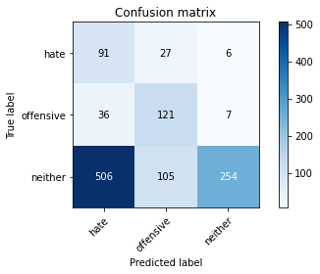

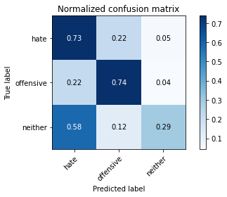

precision recall f1-score support

hate 0.14 0.73 0.24 124

offensive 0.48 0.74 0.58 164

neither 0.95 0.29 0.45 865

accuracy 0.40 1153

macro avg 0.52 0.59 0.42 1153

weighted avg 0.80 0.40 0.45 1153

average eval_loss: 3.20046892248351, accuracy: 0.404163052905464

training 8 epoch...

70.03750252723694 seconds used......

8 training finished! average train loss: 0.05388311387477664

evaluating...

Confusion matrix, without normalization

[[ 75 24 25]

[ 31 117 16]

[321 79 465]]

Normalized confusion matrix

[[0.60483871 0.19354839 0.2016129 ]

[0.18902439 0.71341463 0.09756098]

[0.37109827 0.09132948 0.53757225]]

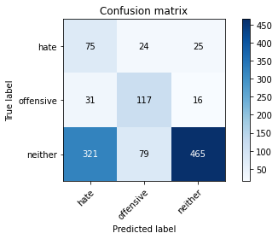

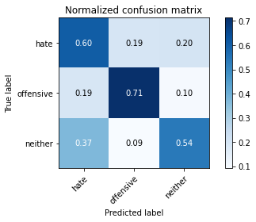

precision recall f1-score support

hate 0.18 0.60 0.27 124

offensive 0.53 0.71 0.61 164

neither 0.92 0.54 0.68 865

accuracy 0.57 1153

macro avg 0.54 0.62 0.52 1153

weighted avg 0.78 0.57 0.62 1153

average eval_loss: 1.9459939516823868, accuracy: 0.5698178664353859

training 9 epoch...

70.14208960533142 seconds used......

9 training finished! average train loss: 0.041274550840690996

evaluating...

Confusion matrix, without normalization

[[ 84 25 15]

[ 33 116 15]

[402 74 389]]

Normalized confusion matrix

[[0.67741935 0.2016129 0.12096774]

[0.20121951 0.70731707 0.09146341]

[0.46473988 0.08554913 0.44971098]]

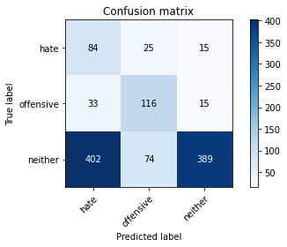

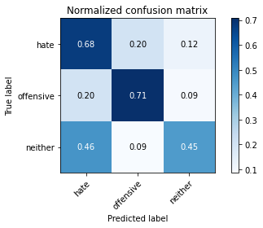

precision recall f1-score support

hate 0.16 0.68 0.26 124

offensive 0.54 0.71 0.61 164

neither 0.93 0.45 0.61 865

accuracy 0.51 1153

macro avg 0.54 0.61 0.49 1153

weighted avg 0.79 0.51 0.57 1153

average eval_loss: 2.4643707593967177, accuracy: 0.5108412836079792

training 10 epoch...

70.10081553459167 seconds used......

10 training finished! average train loss: 0.04303269696607631

evaluating...

Confusion matrix, without normalization

[[ 89 29 6]

[ 40 118 6]

[544 109 212]]

Normalized confusion matrix

[[0.71774194 0.23387097 0.0483871 ]

[0.24390244 0.7195122 0.03658537]

[0.62890173 0.12601156 0.24508671]]

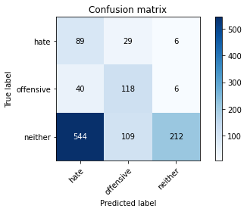

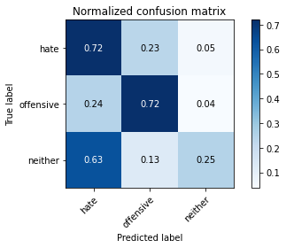

precision recall f1-score support

hate 0.13 0.72 0.22 124

offensive 0.46 0.72 0.56 164

neither 0.95 0.25 0.39 865

accuracy 0.36 1153

macro avg 0.51 0.56 0.39 1153

weighted avg 0.79 0.36 0.40 1153

average eval_loss: 3.6176027388408265, accuracy: 0.3633998265394623

2 run......

training 1 epoch...

70.19149041175842 seconds used......

1 training finished! average train loss: 1.00504919141531

evaluating...

Confusion matrix, without normalization

[[ 50 26 48]

[ 25 103 36]

[115 93 657]]

Normalized confusion matrix

[[0.40322581 0.20967742 0.38709677]

[0.15243902 0.62804878 0.2195122 ]

[0.13294798 0.10751445 0.75953757]]

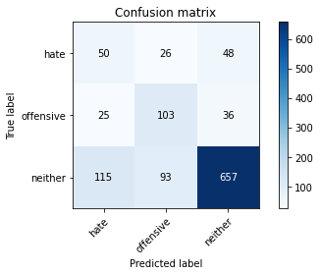

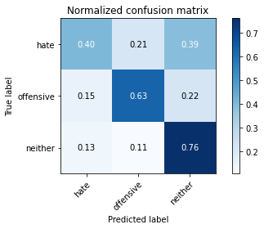

precision recall f1-score support

hate 0.26 0.40 0.32 124

offensive 0.46 0.63 0.53 164

neither 0.89 0.76 0.82 865

accuracy 0.70 1153

macro avg 0.54 0.60 0.56 1153

weighted avg 0.76 0.70 0.72 1153

average eval_loss: 0.8404190622527024, accuracy: 0.7025151777970512

training 2 epoch...

70.05489730834961 seconds used......

2 training finished! average train loss: 0.8461576097068333

evaluating...

Confusion matrix, without normalization

[[ 98 24 2]

[ 43 117 4]

[613 87 165]]

Normalized confusion matrix

[[0.79032258 0.19354839 0.01612903]

[0.26219512 0.71341463 0.02439024]

[0.70867052 0.10057803 0.19075145]]

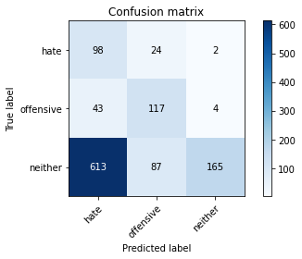

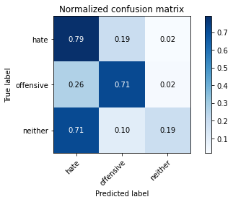

precision recall f1-score support

hate 0.13 0.79 0.22 124

offensive 0.51 0.71 0.60 164

neither 0.96 0.19 0.32 865

accuracy 0.33 1153

macro avg 0.54 0.56 0.38 1153

weighted avg 0.81 0.33 0.35 1153

average eval_loss: 1.0732417774611507, accuracy: 0.3295750216825672

training 3 epoch...

70.13347387313843 seconds used......

3 training finished! average train loss: 0.6716745424838293

evaluating...

Confusion matrix, without normalization

[[ 72 34 18]

[ 34 115 15]

[237 103 525]]

Normalized confusion matrix

[[0.58064516 0.27419355 0.14516129]

[0.20731707 0.70121951 0.09146341]

[0.27398844 0.11907514 0.60693642]]

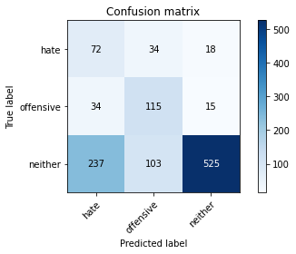

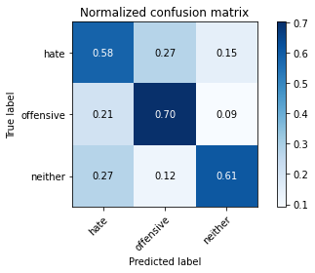

precision recall f1-score support

hate 0.21 0.58 0.31 124

offensive 0.46 0.70 0.55 164

neither 0.94 0.61 0.74 865

accuracy 0.62 1153

macro avg 0.54 0.63 0.53 1153

weighted avg 0.79 0.62 0.67 1153

average eval_loss: 0.9173250182949263, accuracy: 0.6175195143104943

training 4 epoch...

70.14612364768982 seconds used......

4 training finished! average train loss: 0.42389682006268276

evaluating...

Confusion matrix, without normalization

[[ 83 29 12]

[ 40 117 7]

[361 120 384]]

Normalized confusion matrix

[[0.66935484 0.23387097 0.09677419]

[0.24390244 0.71341463 0.04268293]

[0.41734104 0.13872832 0.44393064]]

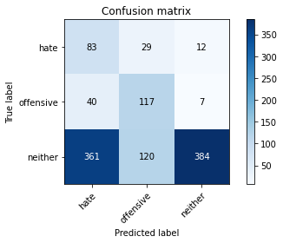

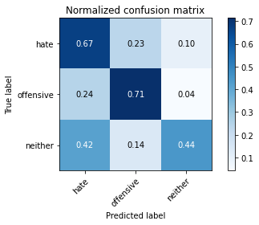

precision recall f1-score support

hate 0.17 0.67 0.27 124

offensive 0.44 0.71 0.54 164

neither 0.95 0.44 0.61 865

accuracy 0.51 1153

macro avg 0.52 0.61 0.47 1153

weighted avg 0.80 0.51 0.56 1153

average eval_loss: 1.4458120691365208, accuracy: 0.5065047701647876

training 5 epoch...

70.12132906913757 seconds used......

5 training finished! average train loss: 0.21090716910770252

evaluating...

Confusion matrix, without normalization

[[ 84 14 26]

[ 53 82 29]

[306 35 524]]

Normalized confusion matrix

[[0.67741935 0.11290323 0.20967742]

[0.32317073 0.5 0.17682927]

[0.35375723 0.04046243 0.60578035]]

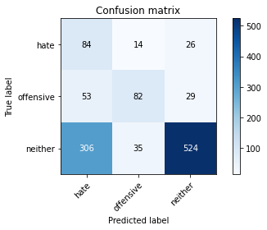

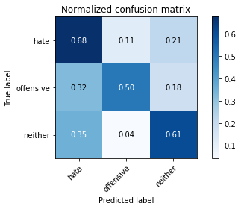

precision recall f1-score support

hate 0.19 0.68 0.30 124

offensive 0.63 0.50 0.56 164

neither 0.91 0.61 0.73 865

accuracy 0.60 1153

macro avg 0.57 0.59 0.53 1153

weighted avg 0.79 0.60 0.66 1153

average eval_loss: 1.2184641515386516, accuracy: 0.598438855160451

training 6 epoch...

70.1024112701416 seconds used......

6 training finished! average train loss: 0.10859935455179463

evaluating...

Confusion matrix, without normalization

[[ 91 19 14]

[ 53 92 19]

[348 62 455]]

Normalized confusion matrix

[[0.73387097 0.15322581 0.11290323]

[0.32317073 0.56097561 0.11585366]

[0.40231214 0.0716763 0.52601156]]

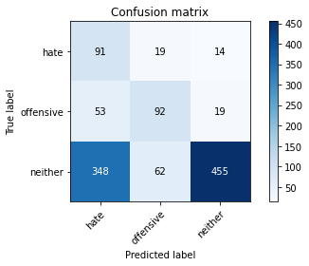

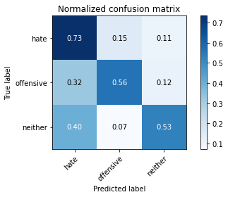

precision recall f1-score support

hate 0.18 0.73 0.30 124

offensive 0.53 0.56 0.55 164

neither 0.93 0.53 0.67 865

accuracy 0.55 1153

macro avg 0.55 0.61 0.50 1153

weighted avg 0.80 0.55 0.61 1153

average eval_loss: 1.8633532873515426, accuracy: 0.5533391153512576

training 7 epoch...

70.12957429885864 seconds used......

7 training finished! average train loss: 0.06274244426389314

evaluating...

Confusion matrix, without normalization

[[ 82 30 12]

[ 34 121 9]

[377 132 356]]

Normalized confusion matrix

[[0.66129032 0.24193548 0.09677419]

[0.20731707 0.73780488 0.05487805]

[0.43583815 0.15260116 0.41156069]]

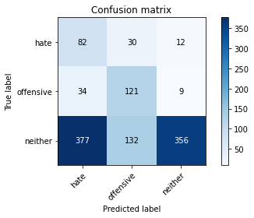

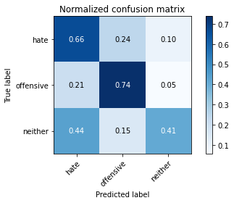

precision recall f1-score support

hate 0.17 0.66 0.27 124

offensive 0.43 0.74 0.54 164

neither 0.94 0.41 0.57 865

accuracy 0.48 1153

macro avg 0.51 0.60 0.46 1153

weighted avg 0.79 0.48 0.54 1153

average eval_loss: 2.5805629964532524, accuracy: 0.48482220294882916

training 8 epoch...

70.11734437942505 seconds used......

8 training finished! average train loss: 0.04038185213825533

evaluating...

Confusion matrix, without normalization

[[ 94 18 12]

[ 55 102 7]

[388 62 415]]

Normalized confusion matrix

[[0.75806452 0.14516129 0.09677419]

[0.33536585 0.62195122 0.04268293]

[0.44855491 0.0716763 0.47976879]]

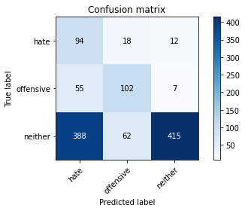

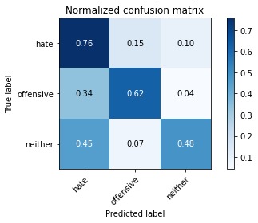

precision recall f1-score support

hate 0.18 0.76 0.28 124

offensive 0.56 0.62 0.59 164

neither 0.96 0.48 0.64 865

accuracy 0.53 1153

macro avg 0.56 0.62 0.50 1153

weighted avg 0.82 0.53 0.59 1153

average eval_loss: 2.5396584005191407, accuracy: 0.5299219427580225

training 9 epoch...

70.11735701560974 seconds used......

9 training finished! average train loss: 0.0306706418292985

evaluating...

Confusion matrix, without normalization

[[ 87 25 12]

[ 49 105 10]

[391 75 399]]

Normalized confusion matrix

[[0.7016129 0.2016129 0.09677419]

[0.29878049 0.6402439 0.06097561]

[0.45202312 0.0867052 0.46127168]]

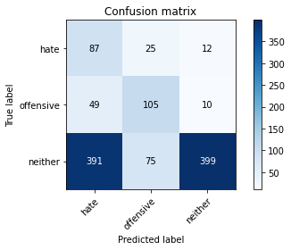

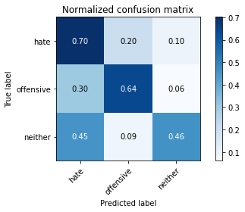

precision recall f1-score support

hate 0.17 0.70 0.27 124

offensive 0.51 0.64 0.57 164

neither 0.95 0.46 0.62 865

accuracy 0.51 1153

macro avg 0.54 0.60 0.49 1153

weighted avg 0.80 0.51 0.58 1153

average eval_loss: 2.5923941567026336, accuracy: 0.5125758889852559

training 10 epoch...

70.12012124061584 seconds used......

10 training finished! average train loss: 0.02989921651931668

evaluating...

Confusion matrix, without normalization

[[ 89 20 15]

[ 52 98 14]

[387 62 416]]

Normalized confusion matrix

[[0.71774194 0.16129032 0.12096774]

[0.31707317 0.59756098 0.08536585]

[0.44739884 0.0716763 0.48092486]]

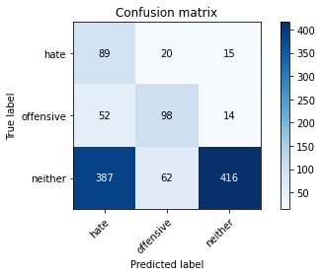

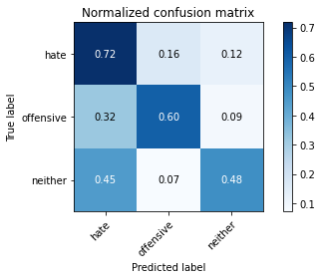

precision recall f1-score support

hate 0.17 0.72 0.27 124

offensive 0.54 0.60 0.57 164

neither 0.93 0.48 0.64 865

accuracy 0.52 1153

macro avg 0.55 0.60 0.49 1153

weighted avg 0.80 0.52 0.59 1153

average eval_loss: 2.50420854831564, accuracy: 0.5229835212489159

3 run......

training 1 epoch...

70.18409538269043 seconds used......

1 training finished! average train loss: 0.997683275668394

evaluating...

Confusion matrix, without normalization

[[ 82 26 16]

[ 32 109 23]

[352 77 436]]

Normalized confusion matrix

[[0.66129032 0.20967742 0.12903226]

[0.19512195 0.66463415 0.1402439 ]

[0.40693642 0.08901734 0.50404624]]

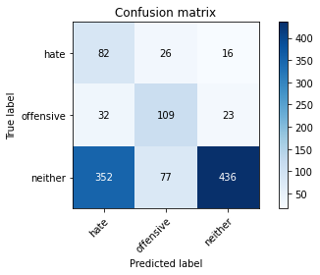

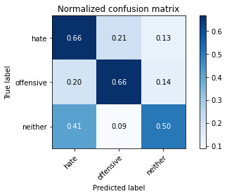

precision recall f1-score support

hate 0.18 0.66 0.28 124

offensive 0.51 0.66 0.58 164

neither 0.92 0.50 0.65 865

accuracy 0.54 1153

macro avg 0.54 0.61 0.50 1153

weighted avg 0.78 0.54 0.60 1153

average eval_loss: 0.8867502654420918, accuracy: 0.5437987857762359

training 2 epoch...

70.1018717288971 seconds used......

2 training finished! average train loss: 0.8500052066076369

evaluating...

Confusion matrix, without normalization

[[ 77 38 9]

[ 35 122 7]

[386 96 383]]

Normalized confusion matrix

[[0.62096774 0.30645161 0.07258065]

[0.21341463 0.74390244 0.04268293]

[0.44624277 0.11098266 0.44277457]]

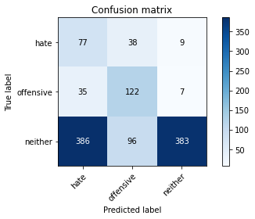

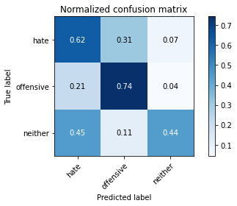

precision recall f1-score support

hate 0.15 0.62 0.25 124

offensive 0.48 0.74 0.58 164

neither 0.96 0.44 0.61 865

accuracy 0.50 1153

macro avg 0.53 0.60 0.48 1153

weighted avg 0.80 0.50 0.56 1153

average eval_loss: 0.9234486684716982, accuracy: 0.5047701647875108

training 3 epoch...

70.1123411655426 seconds used......

3 training finished! average train loss: 0.6987277542551359

evaluating...

Confusion matrix, without normalization

[[ 90 26 8]

[ 39 117 8]

[449 72 344]]

Normalized confusion matrix

[[0.72580645 0.20967742 0.06451613]

[0.23780488 0.71341463 0.04878049]

[0.51907514 0.08323699 0.39768786]]

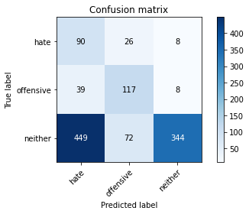

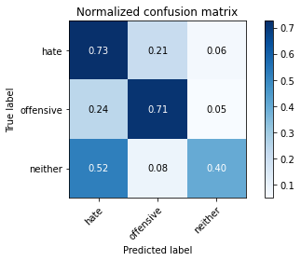

precision recall f1-score support

hate 0.16 0.73 0.26 124

offensive 0.54 0.71 0.62 164

neither 0.96 0.40 0.56 865

accuracy 0.48 1153

macro avg 0.55 0.61 0.48 1153

weighted avg 0.81 0.48 0.54 1153

average eval_loss: 1.1383453145109375, accuracy: 0.4778837814397225

training 4 epoch...

70.09174418449402 seconds used......

4 training finished! average train loss: 0.44406654827651526

evaluating...

Confusion matrix, without normalization

[[ 93 28 3]

[ 56 105 3]

[552 78 235]]

Normalized confusion matrix

[[0.75 0.22580645 0.02419355]

[0.34146341 0.6402439 0.01829268]

[0.63815029 0.09017341 0.2716763 ]]

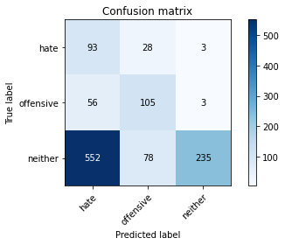

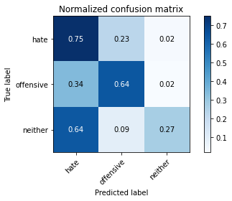

precision recall f1-score support

hate 0.13 0.75 0.23 124

offensive 0.50 0.64 0.56 164

neither 0.98 0.27 0.42 865

accuracy 0.38 1153

macro avg 0.54 0.55 0.40 1153

weighted avg 0.82 0.38 0.42 1153

average eval_loss: 1.8136659346777817, accuracy: 0.375542064180399

training 5 epoch...

70.14089703559875 seconds used......

5 training finished! average train loss: 0.22687946605895246

evaluating...

Confusion matrix, without normalization

[[ 74 31 19]

[ 30 123 11]

[341 80 444]]

Normalized confusion matrix

[[0.59677419 0.25 0.15322581]

[0.18292683 0.75 0.06707317]

[0.39421965 0.09248555 0.5132948 ]]

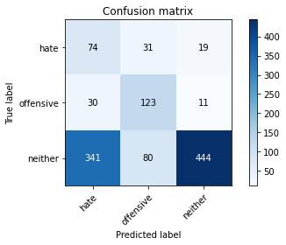

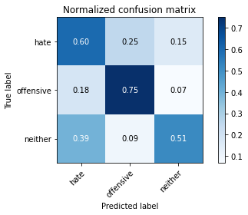

precision recall f1-score support

hate 0.17 0.60 0.26 124

offensive 0.53 0.75 0.62 164

neither 0.94 0.51 0.66 865

accuracy 0.56 1153

macro avg 0.54 0.62 0.51 1153

weighted avg 0.80 0.56 0.61 1153

average eval_loss: 1.6101790358280312, accuracy: 0.5559410234171726

training 6 epoch...

70.1633460521698 seconds used......

6 training finished! average train loss: 0.11207264246019934

evaluating...

Confusion matrix, without normalization

[[ 68 44 12]

[ 29 130 5]

[424 117 324]]

Normalized confusion matrix

[[0.5483871 0.35483871 0.09677419]

[0.17682927 0.79268293 0.0304878 ]

[0.49017341 0.13526012 0.37456647]]

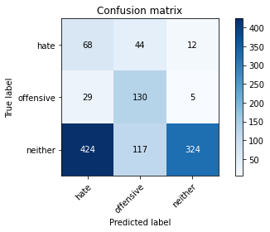

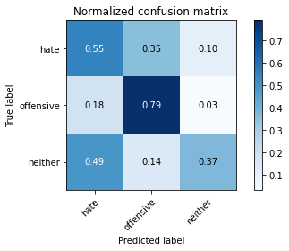

precision recall f1-score support

hate 0.13 0.55 0.21 124

offensive 0.45 0.79 0.57 164

neither 0.95 0.37 0.54 865

accuracy 0.45 1153

macro avg 0.51 0.57 0.44 1153

weighted avg 0.79 0.45 0.51 1153

average eval_loss: 2.6065139873274443, accuracy: 0.4527320034692108

training 7 epoch...

70.07049775123596 seconds used......

7 training finished! average train loss: 0.0828264194438123

evaluating...

Confusion matrix, without normalization

[[ 87 32 5]

[ 41 120 3]

[564 94 207]]

Normalized confusion matrix

[[0.7016129 0.25806452 0.04032258]

[0.25 0.73170732 0.01829268]

[0.65202312 0.10867052 0.23930636]]

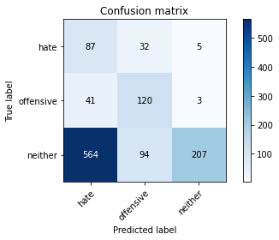

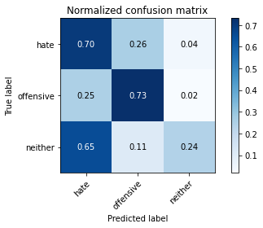

precision recall f1-score support

hate 0.13 0.70 0.21 124

offensive 0.49 0.73 0.59 164

neither 0.96 0.24 0.38 865

accuracy 0.36 1153

macro avg 0.53 0.56 0.39 1153

weighted avg 0.81 0.36 0.39 1153

average eval_loss: 3.45899361371994, accuracy: 0.3590633130962706

training 8 epoch...

70.11438369750977 seconds used......

8 training finished! average train loss: 0.06273702765576586

evaluating...

Confusion matrix, without normalization

[[ 69 33 22]

[ 25 121 18]

[341 93 431]]

Normalized confusion matrix

[[0.55645161 0.26612903 0.17741935]

[0.15243902 0.73780488 0.1097561 ]

[0.39421965 0.10751445 0.4982659 ]]

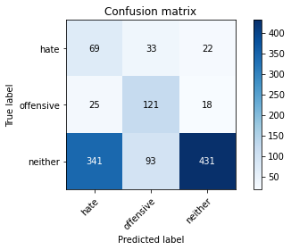

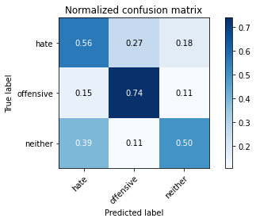

precision recall f1-score support

hate 0.16 0.56 0.25 124

offensive 0.49 0.74 0.59 164

neither 0.92 0.50 0.65 865

accuracy 0.54 1153

macro avg 0.52 0.60 0.49 1153

weighted avg 0.77 0.54 0.59 1153

average eval_loss: 2.21403326659367, accuracy: 0.5385949696444059

training 9 epoch...

70.15091705322266 seconds used......

9 training finished! average train loss: 0.04483443803855196

evaluating...

Confusion matrix, without normalization

[[ 81 28 15]

[ 35 115 14]

[382 93 390]]

Normalized confusion matrix

[[0.65322581 0.22580645 0.12096774]

[0.21341463 0.70121951 0.08536585]

[0.4416185 0.10751445 0.45086705]]

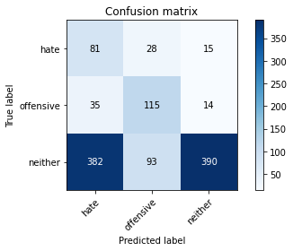

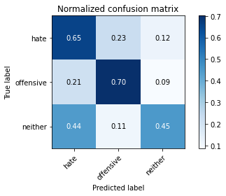

precision recall f1-score support

hate 0.16 0.65 0.26 124

offensive 0.49 0.70 0.57 164

neither 0.93 0.45 0.61 865

accuracy 0.51 1153

macro avg 0.53 0.60 0.48 1153

weighted avg 0.79 0.51 0.57 1153

average eval_loss: 2.484703985781505, accuracy: 0.5082393755420642

training 10 epoch...

70.1616780757904 seconds used......

10 training finished! average train loss: 0.03318924472079657

evaluating...

Confusion matrix, without normalization

[[ 75 33 16]

[ 37 115 12]

[381 83 401]]

Normalized confusion matrix

[[0.60483871 0.26612903 0.12903226]

[0.22560976 0.70121951 0.07317073]

[0.44046243 0.09595376 0.46358382]]

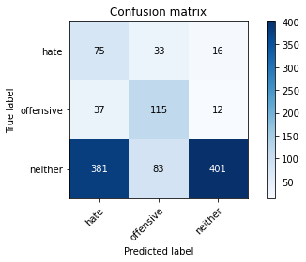

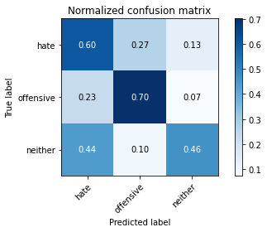

precision recall f1-score support

hate 0.15 0.60 0.24 124

offensive 0.50 0.70 0.58 164

neither 0.93 0.46 0.62 865

accuracy 0.51 1153

macro avg 0.53 0.59 0.48 1153

weighted avg 0.79 0.51 0.57 1153

average eval_loss: 2.7747916168180007, accuracy: 0.5125758889852559

4 run......

training 1 epoch...

70.11491656303406 seconds used......

1 training finished! average train loss: 0.9977107548287937

evaluating...

Confusion matrix, without normalization

[[ 99 25 0]

[ 54 109 1]

[725 79 61]]

Normalized confusion matrix

[[0.7983871 0.2016129 0. ]

[0.32926829 0.66463415 0.00609756]

[0.83815029 0.09132948 0.07052023]]

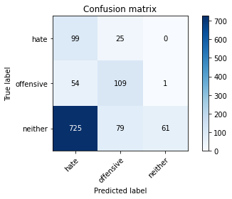

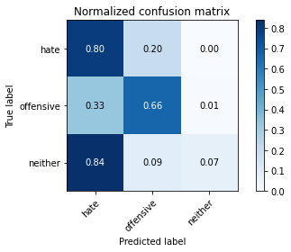

precision recall f1-score support

hate 0.11 0.80 0.20 124

offensive 0.51 0.66 0.58 164

neither 0.98 0.07 0.13 865

accuracy 0.23 1153

macro avg 0.54 0.51 0.30 1153

weighted avg 0.82 0.23 0.20 1153

average eval_loss: 1.034154421296613, accuracy: 0.23330442324371206

training 2 epoch...

70.09531021118164 seconds used......

2 training finished! average train loss: 0.8661033649529729

evaluating...

Confusion matrix, without normalization

[[ 72 41 11]

[ 29 129 6]

[435 126 304]]

Normalized confusion matrix

[[0.58064516 0.33064516 0.08870968]

[0.17682927 0.78658537 0.03658537]

[0.50289017 0.14566474 0.35144509]]

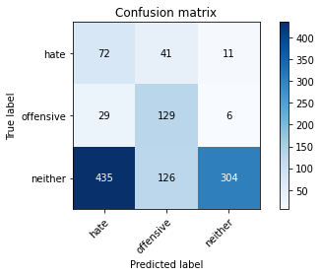

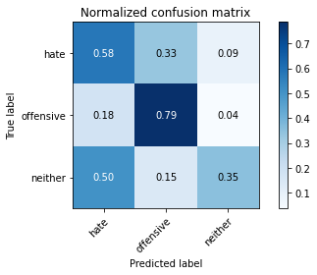

precision recall f1-score support

hate 0.13 0.58 0.22 124

offensive 0.44 0.79 0.56 164

neither 0.95 0.35 0.51 865

accuracy 0.44 1153

macro avg 0.51 0.57 0.43 1153

weighted avg 0.79 0.44 0.49 1153

average eval_loss: 0.9638725036177141, accuracy: 0.43798785776235905

training 3 epoch...

70.07657551765442 seconds used......

3 training finished! average train loss: 0.7267419699402082

evaluating...

Confusion matrix, without normalization

[[ 85 17 22]

[ 48 102 14]

[328 41 496]]

Normalized confusion matrix

[[0.68548387 0.13709677 0.17741935]

[0.29268293 0.62195122 0.08536585]

[0.37919075 0.04739884 0.5734104 ]]

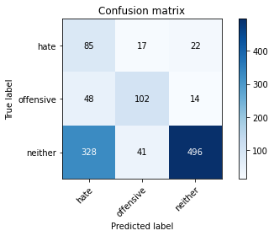

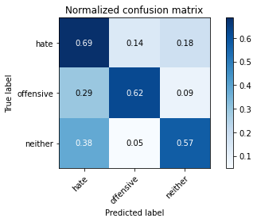

precision recall f1-score support

hate 0.18 0.69 0.29 124

offensive 0.64 0.62 0.63 164

neither 0.93 0.57 0.71 865

accuracy 0.59 1153

macro avg 0.58 0.63 0.54 1153

weighted avg 0.81 0.59 0.65 1153

average eval_loss: 0.8261369312631672, accuracy: 0.5923677363399826

training 4 epoch...

70.12759137153625 seconds used......

4 training finished! average train loss: 0.509503764056024

evaluating...

Confusion matrix, without normalization

[[ 72 31 21]

[ 25 124 15]

[270 87 508]]

Normalized confusion matrix

[[0.58064516 0.25 0.16935484]

[0.15243902 0.75609756 0.09146341]

[0.31213873 0.10057803 0.58728324]]

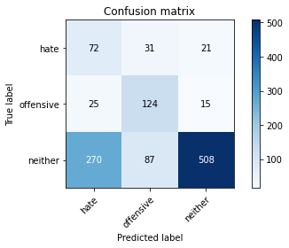

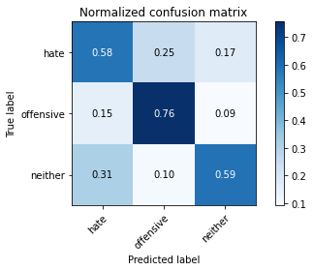

precision recall f1-score support

hate 0.20 0.58 0.29 124

offensive 0.51 0.76 0.61 164

neither 0.93 0.59 0.72 865

accuracy 0.61 1153

macro avg 0.55 0.64 0.54 1153

weighted avg 0.79 0.61 0.66 1153

average eval_loss: 0.9741453466744259, accuracy: 0.6105810928013877

training 5 epoch...

70.12559390068054 seconds used......

5 training finished! average train loss: 0.2616013213326888

evaluating...

Confusion matrix, without normalization

[[ 88 21 15]

[ 43 107 14]

[408 69 388]]

Normalized confusion matrix

[[0.70967742 0.16935484 0.12096774]

[0.26219512 0.65243902 0.08536585]

[0.4716763 0.07976879 0.44855491]]

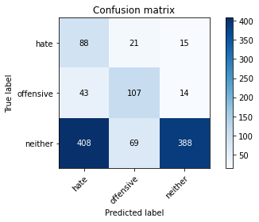

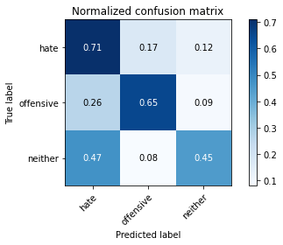

precision recall f1-score support

hate 0.16 0.71 0.27 124

offensive 0.54 0.65 0.59 164

neither 0.93 0.45 0.61 865

accuracy 0.51 1153

macro avg 0.55 0.60 0.49 1153

weighted avg 0.79 0.51 0.57 1153

average eval_loss: 1.7153244069938003, accuracy: 0.5056374674761491

training 6 epoch...

70.09311079978943 seconds used......

6 training finished! average train loss: 0.12018400643553052

evaluating...

Confusion matrix, without normalization

[[101 6 17]

[ 72 79 13]

[476 39 350]]

Normalized confusion matrix

[[0.81451613 0.0483871 0.13709677]

[0.43902439 0.48170732 0.07926829]

[0.55028902 0.04508671 0.40462428]]

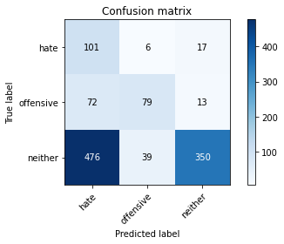

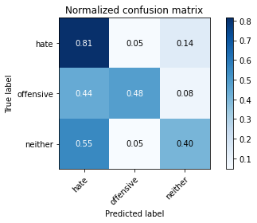

precision recall f1-score support

hate 0.16 0.81 0.26 124

offensive 0.64 0.48 0.55 164

neither 0.92 0.40 0.56 865

accuracy 0.46 1153

macro avg 0.57 0.57 0.46 1153

weighted avg 0.80 0.46 0.53 1153

average eval_loss: 2.519193651347325, accuracy: 0.45967042497831745

training 7 epoch...

70.16851472854614 seconds used......

7 training finished! average train loss: 0.0697632075697627

evaluating...

Confusion matrix, without normalization

[[ 82 22 20]

[ 38 109 17]

[339 73 453]]

Normalized confusion matrix

[[0.66129032 0.17741935 0.16129032]

[0.23170732 0.66463415 0.10365854]

[0.39190751 0.08439306 0.52369942]]

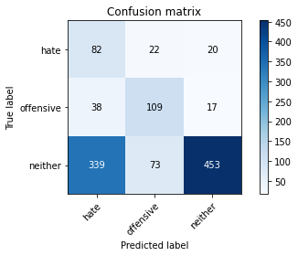

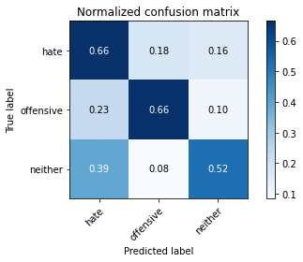

precision recall f1-score support

hate 0.18 0.66 0.28 124

offensive 0.53 0.66 0.59 164

neither 0.92 0.52 0.67 865

accuracy 0.56 1153

macro avg 0.55 0.62 0.51 1153

weighted avg 0.79 0.56 0.62 1153

average eval_loss: 2.0352811320074675, accuracy: 0.5585429314830876

training 8 epoch...

70.25013661384583 seconds used......

8 training finished! average train loss: 0.06661232181275929

evaluating...

Confusion matrix, without normalization

[[ 82 22 20]

[ 40 105 19]

[363 63 439]]

Normalized confusion matrix

[[0.66129032 0.17741935 0.16129032]

[0.24390244 0.6402439 0.11585366]

[0.41965318 0.07283237 0.50751445]]

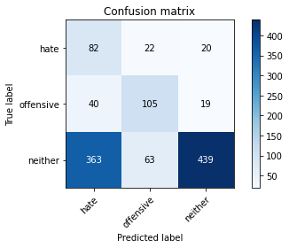

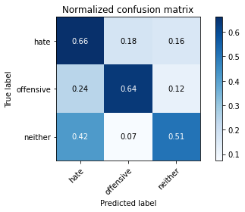

precision recall f1-score support

hate 0.17 0.66 0.27 124

offensive 0.55 0.64 0.59 164

neither 0.92 0.51 0.65 865

accuracy 0.54 1153

macro avg 0.55 0.60 0.51 1153

weighted avg 0.79 0.54 0.60 1153

average eval_loss: 2.224063054240983, accuracy: 0.5429314830875975

training 9 epoch...

70.14027070999146 seconds used......

9 training finished! average train loss: 0.03319010475076668

evaluating...

Confusion matrix, without normalization

[[ 73 35 16]

[ 32 118 14]

[395 86 384]]

Normalized confusion matrix

[[0.58870968 0.28225806 0.12903226]

[0.19512195 0.7195122 0.08536585]

[0.4566474 0.09942197 0.44393064]]

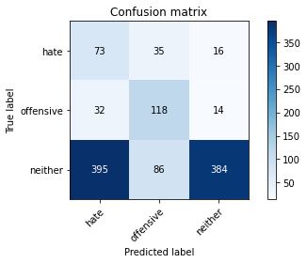

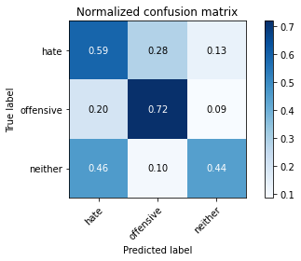

precision recall f1-score support

hate 0.15 0.59 0.23 124

offensive 0.49 0.72 0.59 164

neither 0.93 0.44 0.60 865

accuracy 0.50 1153

macro avg 0.52 0.58 0.47 1153

weighted avg 0.78 0.50 0.56 1153

average eval_loss: 2.869015130503424, accuracy: 0.4986990459670425

training 10 epoch...

70.1131956577301 seconds used......

10 training finished! average train loss: 0.04370236265683724

evaluating...

Confusion matrix, without normalization

[[103 9 12]

[ 62 88 14]

[526 36 303]]

Normalized confusion matrix

[[0.83064516 0.07258065 0.09677419]

[0.37804878 0.53658537 0.08536585]

[0.60809249 0.0416185 0.35028902]]

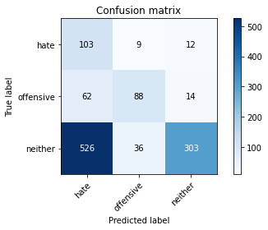

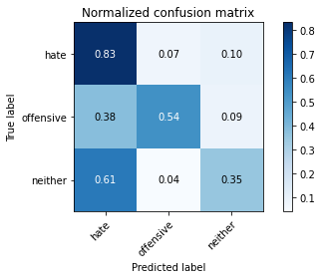

precision recall f1-score support

hate 0.15 0.83 0.25 124

offensive 0.66 0.54 0.59 164

neither 0.92 0.35 0.51 865

accuracy 0.43 1153

macro avg 0.58 0.57 0.45 1153

weighted avg 0.80 0.43 0.49 1153

average eval_loss: 3.4664324254825196, accuracy: 0.4284475281873374

5 run......

training 1 epoch...

70.1371123790741 seconds used......

1 training finished! average train loss: 1.005067683401562

evaluating...

Confusion matrix, without normalization

[[ 97 23 4]

[ 51 111 2]

[524 89 252]]

Normalized confusion matrix

[[0.78225806 0.18548387 0.03225806]

[0.31097561 0.67682927 0.01219512]

[0.60578035 0.10289017 0.29132948]]

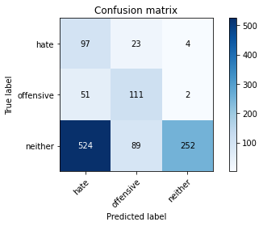

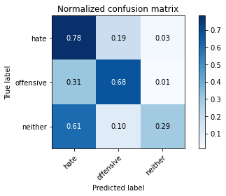

precision recall f1-score support

hate 0.14 0.78 0.24 124

offensive 0.50 0.68 0.57 164

neither 0.98 0.29 0.45 865

accuracy 0.40 1153

macro avg 0.54 0.58 0.42 1153

weighted avg 0.82 0.40 0.44 1153

average eval_loss: 0.9860342227179428, accuracy: 0.398959236773634

training 2 epoch...

70.1330029964447 seconds used......

2 training finished! average train loss: 0.8565516713119689

evaluating...

Confusion matrix, without normalization

[[ 90 26 8]

[ 39 118 7]

[387 101 377]]

Normalized confusion matrix

[[0.72580645 0.20967742 0.06451613]

[0.23780488 0.7195122 0.04268293]

[0.44739884 0.11676301 0.43583815]]

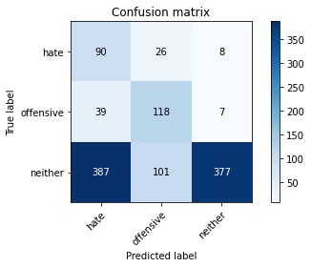

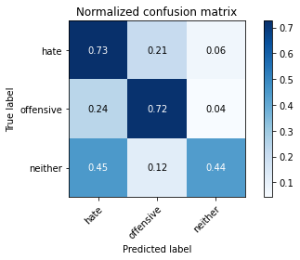

precision recall f1-score support

hate 0.17 0.73 0.28 124

offensive 0.48 0.72 0.58 164

neither 0.96 0.44 0.60 865

accuracy 0.51 1153

macro avg 0.54 0.63 0.49 1153

weighted avg 0.81 0.51 0.56 1153

average eval_loss: 0.9045538224022964, accuracy: 0.5073720728534259

training 3 epoch...

70.13258290290833 seconds used......

3 training finished! average train loss: 0.6973702231688159

evaluating...

Confusion matrix, without normalization

[[ 88 26 10]

[ 40 116 8]

[368 93 404]]

Normalized confusion matrix

[[0.70967742 0.20967742 0.08064516]

[0.24390244 0.70731707 0.04878049]

[0.42543353 0.10751445 0.46705202]]

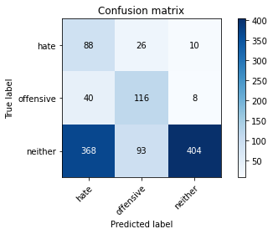

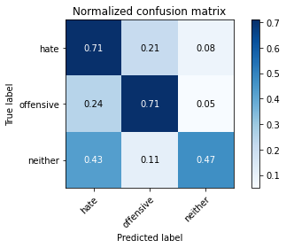

precision recall f1-score support

hate 0.18 0.71 0.28 124

offensive 0.49 0.71 0.58 164

neither 0.96 0.47 0.63 865

accuracy 0.53 1153

macro avg 0.54 0.63 0.50 1153

weighted avg 0.81 0.53 0.58 1153

average eval_loss: 0.9225796625531953, accuracy: 0.5273200346921075

training 4 epoch...

70.23271322250366 seconds used......

4 training finished! average train loss: 0.4611725423130251

evaluating...

Confusion matrix, without normalization

[[ 76 26 22]

[ 40 108 16]

[293 70 502]]

Normalized confusion matrix

[[0.61290323 0.20967742 0.17741935]

[0.24390244 0.65853659 0.09756098]

[0.33872832 0.08092486 0.58034682]]

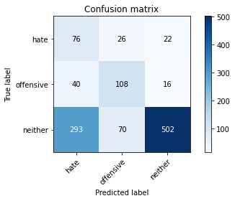

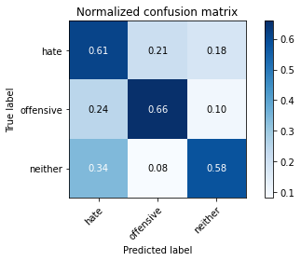

precision recall f1-score support

hate 0.19 0.61 0.29 124

offensive 0.53 0.66 0.59 164

neither 0.93 0.58 0.71 865

accuracy 0.59 1153

macro avg 0.55 0.62 0.53 1153

weighted avg 0.79 0.59 0.65 1153

average eval_loss: 0.9967995327094505, accuracy: 0.5949696444058976

training 5 epoch...

70.22475457191467 seconds used......

5 training finished! average train loss: 0.2135367432187888

evaluating...

Confusion matrix, without normalization

[[ 93 22 9]

[ 47 112 5]

[528 84 253]]

Normalized confusion matrix

[[0.75 0.17741935 0.07258065]

[0.28658537 0.68292683 0.0304878 ]

[0.61040462 0.09710983 0.29248555]]

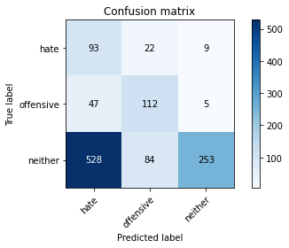

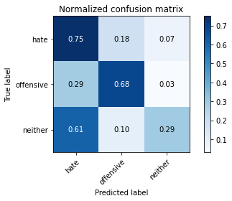

precision recall f1-score support

hate 0.14 0.75 0.23 124

offensive 0.51 0.68 0.59 164

neither 0.95 0.29 0.45 865

accuracy 0.40 1153

macro avg 0.53 0.58 0.42 1153

weighted avg 0.80 0.40 0.44 1153

average eval_loss: 2.206770588611734, accuracy: 0.39722463139635733

training 6 epoch...

70.16365766525269 seconds used......

6 training finished! average train loss: 0.1008436047427711

evaluating...

Confusion matrix, without normalization

[[ 92 24 8]

[ 45 112 7]

[498 84 283]]

Normalized confusion matrix

[[0.74193548 0.19354839 0.06451613]

[0.27439024 0.68292683 0.04268293]

[0.57572254 0.09710983 0.32716763]]

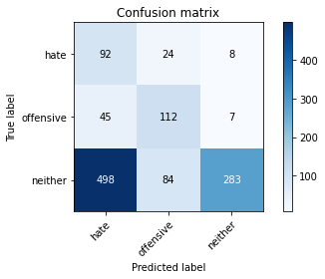

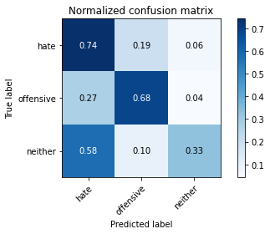

precision recall f1-score support

hate 0.14 0.74 0.24 124

offensive 0.51 0.68 0.58 164

neither 0.95 0.33 0.49 865

accuracy 0.42 1153

macro avg 0.53 0.58 0.44 1153

weighted avg 0.80 0.42 0.47 1153

average eval_loss: 2.7123137342518775, accuracy: 0.42237640936686904

training 7 epoch...

70.24677515029907 seconds used......

7 training finished! average train loss: 0.061878962345266096

evaluating...

Confusion matrix, without normalization

[[ 88 20 16]

[ 44 112 8]

[418 84 363]]

Normalized confusion matrix

[[0.70967742 0.16129032 0.12903226]

[0.26829268 0.68292683 0.04878049]

[0.48323699 0.09710983 0.41965318]]

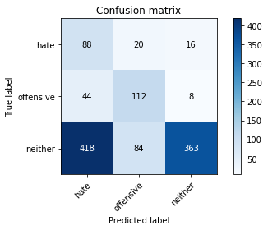

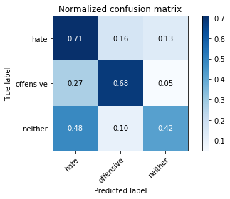

precision recall f1-score support

hate 0.16 0.71 0.26 124

offensive 0.52 0.68 0.59 164

neither 0.94 0.42 0.58 865

accuracy 0.49 1153

macro avg 0.54 0.60 0.48 1153

weighted avg 0.79 0.49 0.55 1153

average eval_loss: 2.543766428684366, accuracy: 0.48829141370338247

training 8 epoch...

70.21323990821838 seconds used......

8 training finished! average train loss: 0.05228920382519607

evaluating...

Confusion matrix, without normalization

[[ 99 16 9]

[ 46 106 12]

[450 72 343]]

Normalized confusion matrix

[[0.7983871 0.12903226 0.07258065]

[0.2804878 0.64634146 0.07317073]

[0.52023121 0.08323699 0.39653179]]

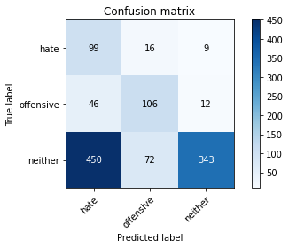

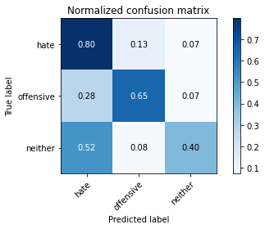

precision recall f1-score support

hate 0.17 0.80 0.28 124

offensive 0.55 0.65 0.59 164

neither 0.94 0.40 0.56 865

accuracy 0.48 1153

macro avg 0.55 0.61 0.48 1153

weighted avg 0.80 0.48 0.53 1153

average eval_loss: 2.6510704241949936, accuracy: 0.47528187337380745

training 9 epoch...

70.20609712600708 seconds used......

9 training finished! average train loss: 0.03181870658833456

evaluating...

Confusion matrix, without normalization

[[ 83 20 21]

[ 35 114 15]

[307 84 474]]

Normalized confusion matrix

[[0.66935484 0.16129032 0.16935484]

[0.21341463 0.69512195 0.09146341]

[0.35491329 0.09710983 0.54797688]]

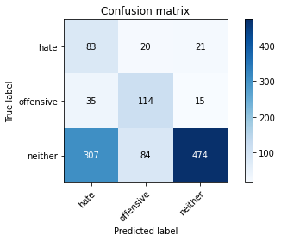

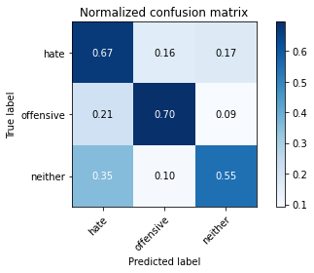

precision recall f1-score support

hate 0.20 0.67 0.30 124

offensive 0.52 0.70 0.60 164

neither 0.93 0.55 0.69 865

accuracy 0.58 1153

macro avg 0.55 0.64 0.53 1153

weighted avg 0.79 0.58 0.63 1153

average eval_loss: 2.2605093820341704, accuracy: 0.5819601040763226

training 10 epoch...

70.15331721305847 seconds used......

10 training finished! average train loss: 0.031404981318268084

evaluating...

Confusion matrix, without normalization

[[ 74 19 31]

[ 40 102 22]

[333 46 486]]

Normalized confusion matrix

[[0.59677419 0.15322581 0.25 ]

[0.24390244 0.62195122 0.13414634]

[0.3849711 0.05317919 0.56184971]]

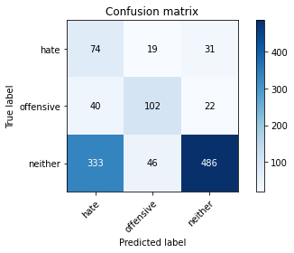

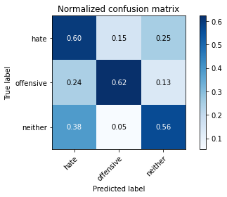

precision recall f1-score support

hate 0.17 0.60 0.26 124

offensive 0.61 0.62 0.62 164

neither 0.90 0.56 0.69 865

accuracy 0.57 1153

macro avg 0.56 0.59 0.52 1153

weighted avg 0.78 0.57 0.63 1153

average eval_loss: 2.1171354178724617, accuracy: 0.5741543798785776